Charity Management System

Member 1: Muhammad Umaid Khan Khakwani
Member 2: Waqas Ahmad
Member 3: Muhammad Fozan
Member 4: Taimur Abid

Table of Contents
Title page 1
Members 2
Functional requirements 4
Use cases 5
Extended Use cases 6
UC1: send notifications 6
UC2: Manage Funds 7
UC3: Prioritize Recipients 8
UC4: Request Charity 9
UC5: Choose Donation Category 10
Domain Model 11
SSD 12
Operation Contracts 14
Sequence Diagrams 16
Application of GRASP on design of use cases 18
Op 1: makeNewDonation() 18
Op 2: makePayment() 19
Op 3 : makeNewRequest() 20
Code Skeleton 21
Main.cpp 21
Recipient.h 22
Donor.h 23
Admin.h 24
Register.h 25
Request.h 26
Donation.h 27
Payment.h 28

Functional requirements: -
- System should allow users to choose the category of donations e.g health, education etc.
- The system shall allow the administrator to manage donations.
- The system should be able to show the progress of the charity.
- The system shall allow the administrator to view individual funds and sent mail to them.
- The system should be able to show the total donation made by regular donors.
- The system should allow the administrator to set the priority of the charity requests.
- The system should allow the user to make requests.
- The system should allow the user to donate to the system.

Use Case Diagram: -
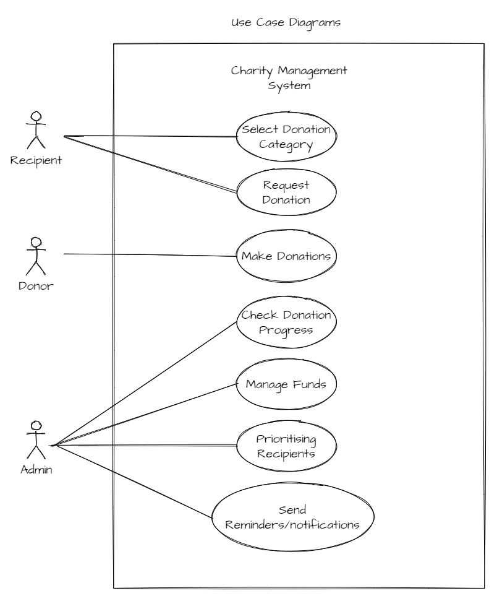

Extended Use Cases: -
- Use Case Name:
Send reminders/notifications.
Scope:
Charity Management System
Level:
User Goal
Primary Actor:
Admin
Stakeholders and Interests:
Admin: admin send the notifications/reminders to the Donors about the donation. And if the recipients send the request, then system notifies the Donors that charity is needed.
Donor: get notified about the charity.
Recipient: get notified about the charity.
Precondition:
Admin should know the social details of the Donors and Recipients to notify them.
Admin is logged in to the system.
Success Guarantee:
Notification is saved into the database.
Main Success Scenario:
Admin | System
2) Admin selects “send notifications”.  4) Admin selects user.  - Admin enters cnic, subject and description. | 1) System displays admin options.  3) System asks user options such as donor or recipient.  5) System displays user lists.

Extensions:
1 a) If system is not responding due to heavy traffic, then wait for some time and then try again to log in or mail the help center.
6 a) If user enters a cnic that is not present in the list then steps 5 and 6 are repeated.

- Use Case Name:
Manage Funds
Scope:
Charity Management System
Level:
User Goal
Primary Actor:
Admin
Stakeholders and Interests:
Admin: Admin cares about this use case in order to keep a check and balance on the finance.
Precondition:
Admin is logged in to the system.
Success Guarantee:
On successful completion, funds must be transferred to the recipients, withdrawn or added on the system.
Main Success Scenario:
Admin | System
2) Admin selects “manage funds”.  4) Admin selects ID. | 1) System displays admin options.  3) System displays request lists.

Extensions:
1 a) If system is not responding due to heavy traffic, then wait for some time and then try again to log in or mail the help center.
4 a) If user enters a id that is not present in the list then steps 3 and 4 are repeated.

- Use Case Name:
Prioritize Recipient
Scope:
Charity Management System
Level:
User Goal
Primary Actor:
Admin
Stakeholders and Interests:
Admin: Admin cares about this use case in order to prioritize the next recipient for charity.
Precondition:
Admin is logged in to the system. There are requests pending to be donated.
Success Guarantee:
Priority is updated in the database against the request. The sorted list of requests in updated.
Main Success Scenario:
Admin | System
2) Admin selects “prioritize recipient”.  4) Admin selects ID.  6) Admin enters priority. | 1) System displays admin options.  3) System displays request lists.  5) System asks priority to assign.  7) System displays prioritized request list.

Extensions:

1 a) If system is not responding due to heavy traffic, then wait for some time and then try again to log in or mail the help center.
4 a) If user enters a id that is not present in the list then steps 3 and 4 are repeated.
6 a) If user enters priority out of range, then steps 5 and 6 are repeated.

- Use Case Name:
Request Charity
Scope:
Charity Management System
Level:
User Goal
Primary Actor:
Recipient
Stakeholders and Interests:
Recipient: Recipient wants to get the request fulfilled in minimum amount of time.
Precondition:
Recipient is logged in to the system.
Success Guarantee:
Request is added in the database.
Main Success Scenario:
Recipient | System
2) Recipient selects “request donation”.  4) Recipient enters the amount. | 1) System displays recipient options.  3) System asks amount.  5) System validates the amount.

Extensions:
1 a) If system is not responding due to heavy traffic, then wait for some time and then try again to log in or mail the help center.
2 a) If Recipient selects invalid option step 1 and 2 are repeated.
5 a) If Recipient enters an invalid amount the step 3, 4 and 5 are repeated.

- Use Case Name:
Choose donation category
Scope:
Charity Management System
Level:
User Goal
Primary Actor:
Recipient
Stakeholders and Interests:
Recipient: Recipient wants to get the request fulfilled in minimum amount of time.
Precondition:
Recipient is logged in to the system.
Recipient has created a new request.
Success Guarantee:
Request is added in the database.
Main Success Scenario:
Recipient | System
2) Recipient selects category.  4) Recipient enters description. | 1) System displays category list.  3) System asks description.

Extensions:
1 a) If system is not responding due to heavy traffic, then wait for some time and then try again to log in or mail the help center.
2 a) If Recipient selects invalid option step 1 and 2 are repeated.

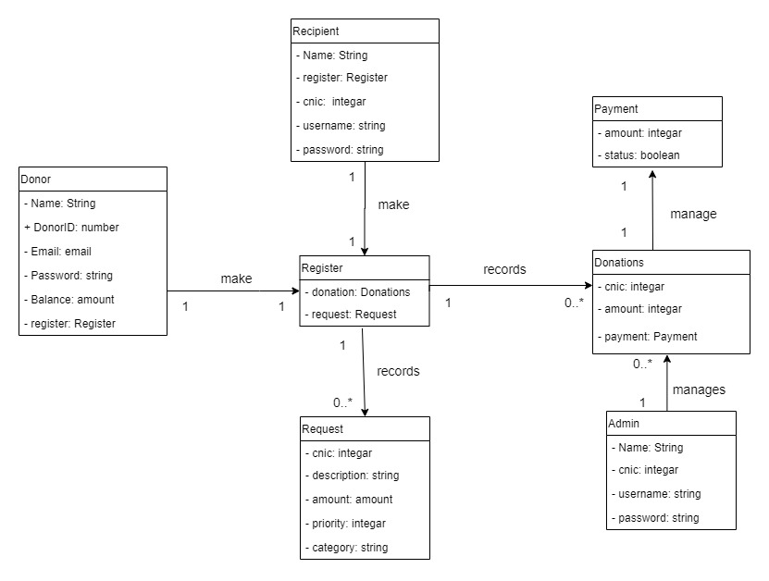
Domain Model: -

SSD: -
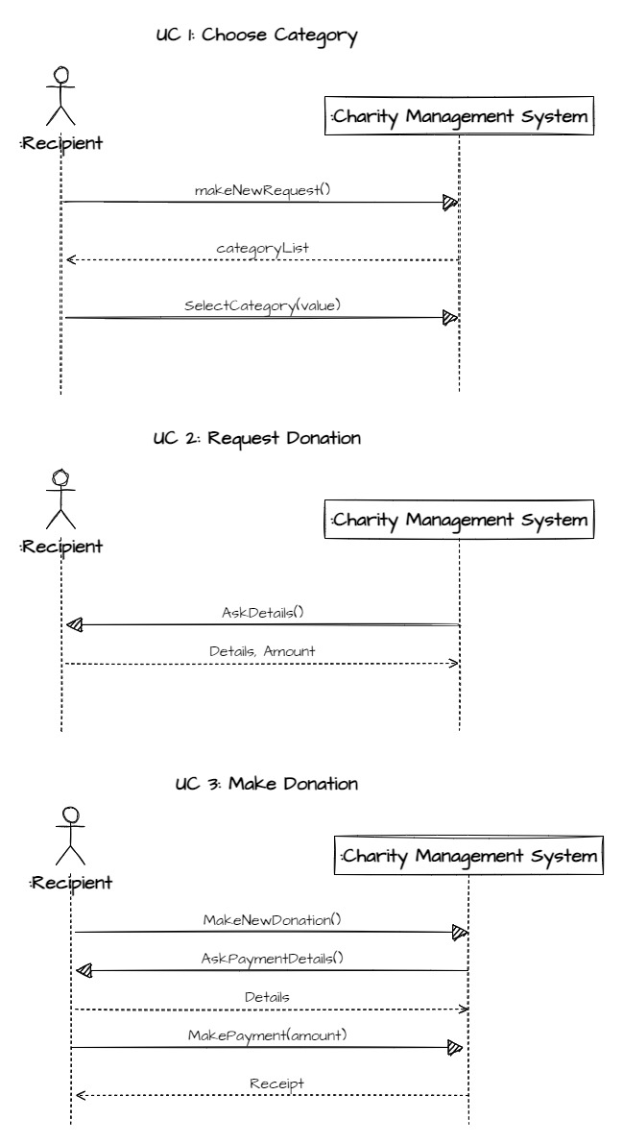

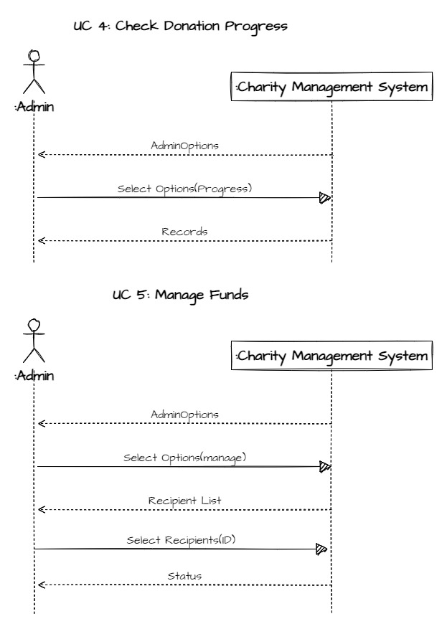

Operation Contracts: -

- Opeation: makeNewDonation()
Cross Reference: makeDonation
Pre-condition: none
Post-condition:
- A donation instance D was created.
- D was associated with Register.
- Attributes of D were initialized.

- Opeation: makePayment(amount: Money)
Cross Reference: makeDonation
Pre-condition: There is a donation underway
Post-condition:
- A payment instance P was created.
- P.amount tendered became amount.
- P was associated with current donation.

- Opeation: makeNewRequest()
Cross Reference: chooseDonation category
Pre-condition: none
Post-condition:
- A request instance R was created.
- R was associated with register.
- Attributes of R were initialized.

- Opeation: changePriority(value: int)
Cross Reference: Prioritize Recipients
Pre-condition: Recipients successfully submitted the request.
Post-condition:
- Recipient’s request attribute R.priority became value.
- Recipient’s request list is sorted based on priority.

- Opeation: manageFunds()
Cross Reference: manage funds
Pre-condition: Admin is logged in to the system
Post-condition:
- Total_funds attribute was updated.
- Recipient’s request list is updated.

Sequence Diagrams: -
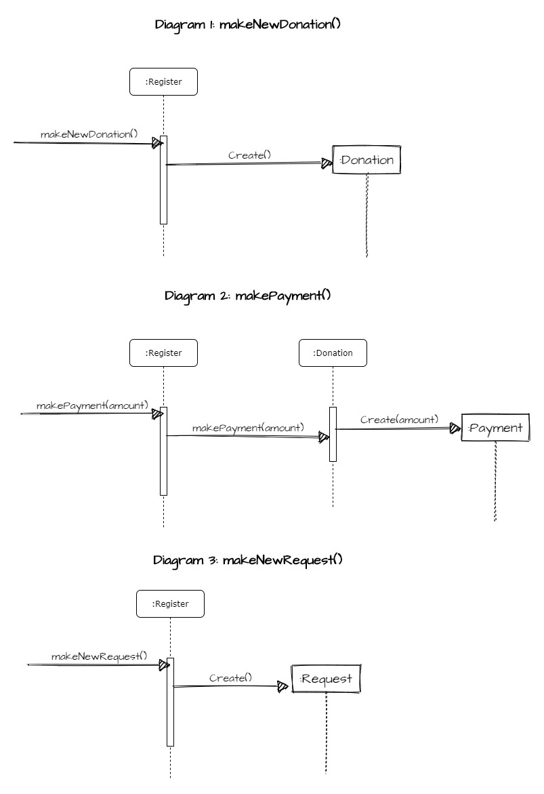

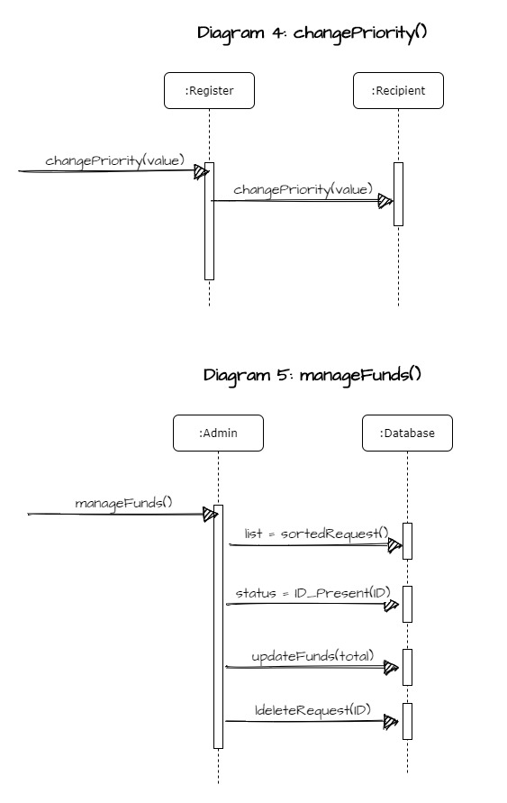
Application of GRASP on the design of use cases: -
- Opeation: makeNewDonation()
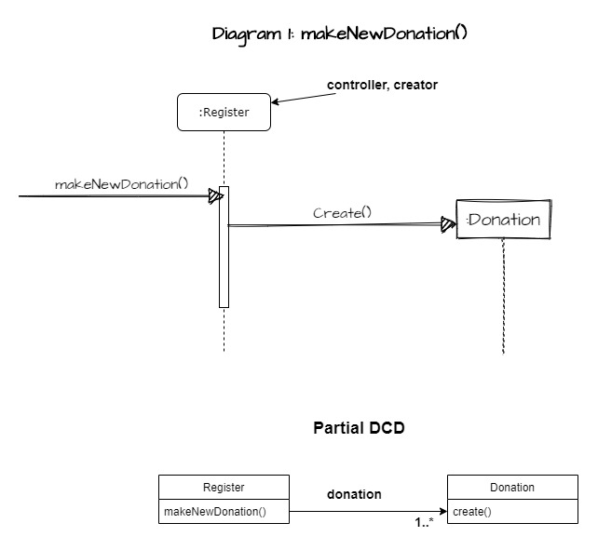
- Based on controller pattern, as for makeNewDonation, we will continue to use Register as a controller.
- Low coupling as classes are independent.
- Register creates new instance of Donation so Register is also creator.

- Opeation: makePayment(amount: Money)
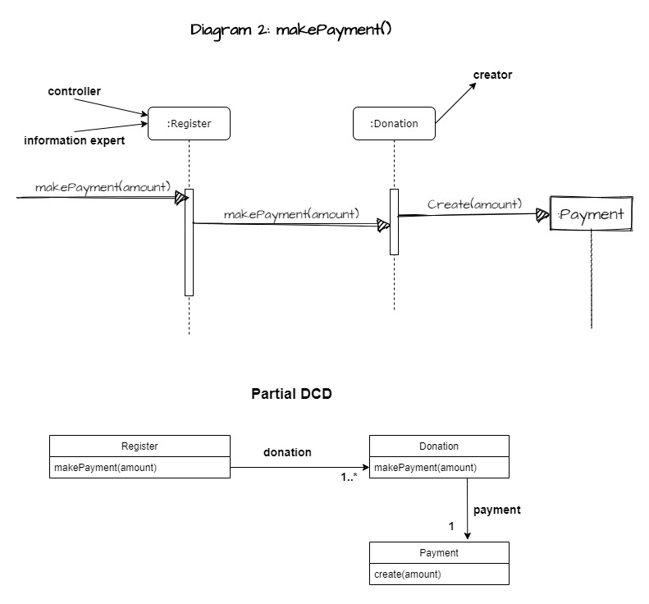
- Our first choice involves the responsibility for the system operation message MakePayment. Based on the controller pattern, we will continue to use Register as a controller.
- By creator, MakePayment message is sent to a Donation for it to create a payment. The Donation creates a payment and then stores the new instance in its permanent collection.
- Register will be Information Expert as it contains amount for payment.
- Low coupling as dependancy is less.
- High cohesion as all classes do relevent tasks.

- Opeation: makeNewRequest()
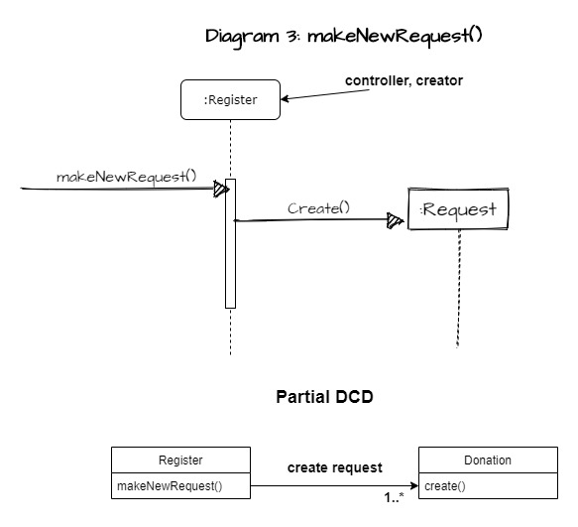
- Low coupling as classes are independent.
- Register creates new instance of request so Register is also creator.
- Our first choice involves the responsibility for the system operation message MakeNewRequest. Based on the controller pattern, we will continue to use Register as a controller

Code Skeleton: -

Main.cpp:
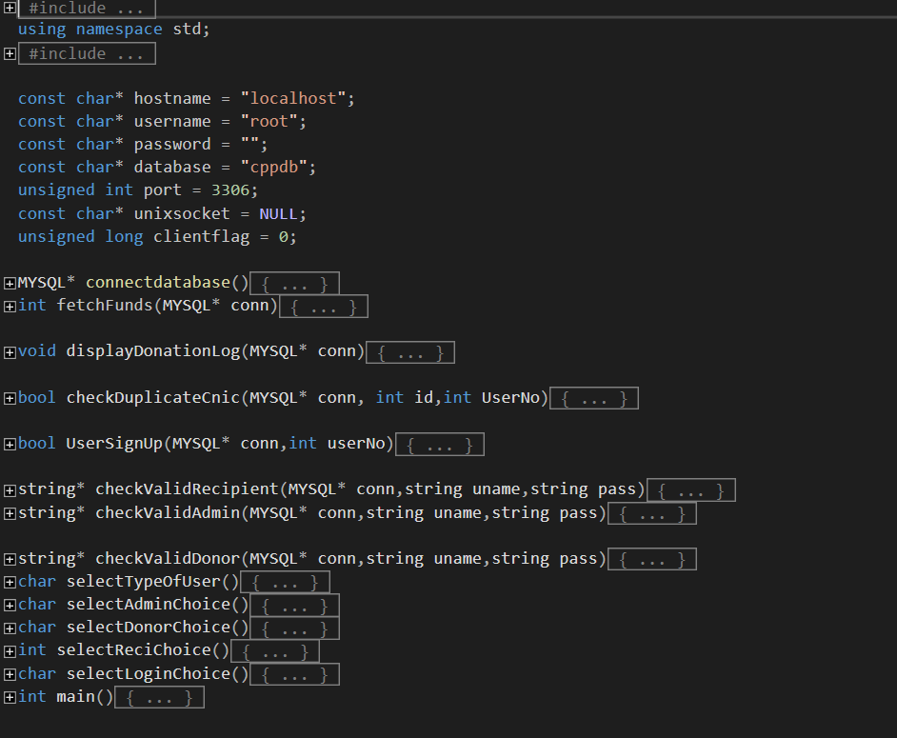

Recipient.h:
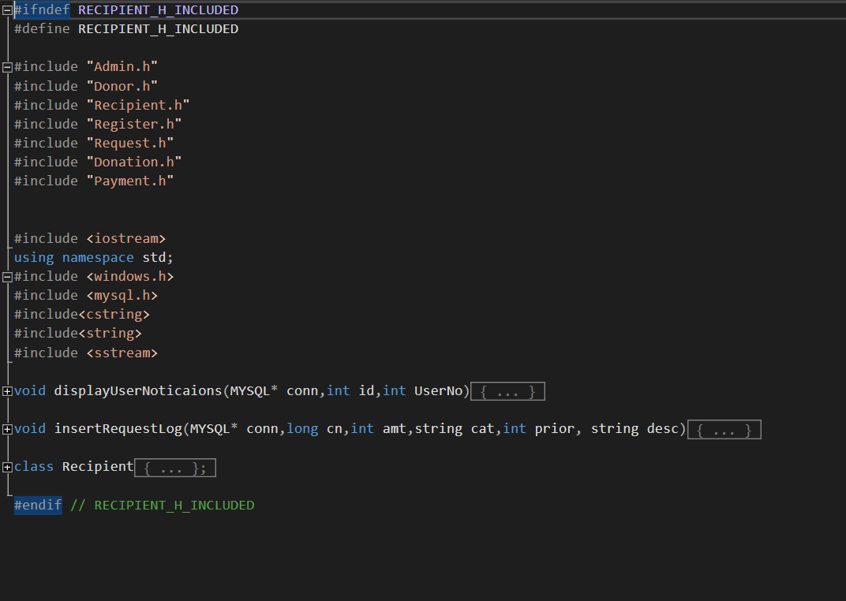

Donor.h:

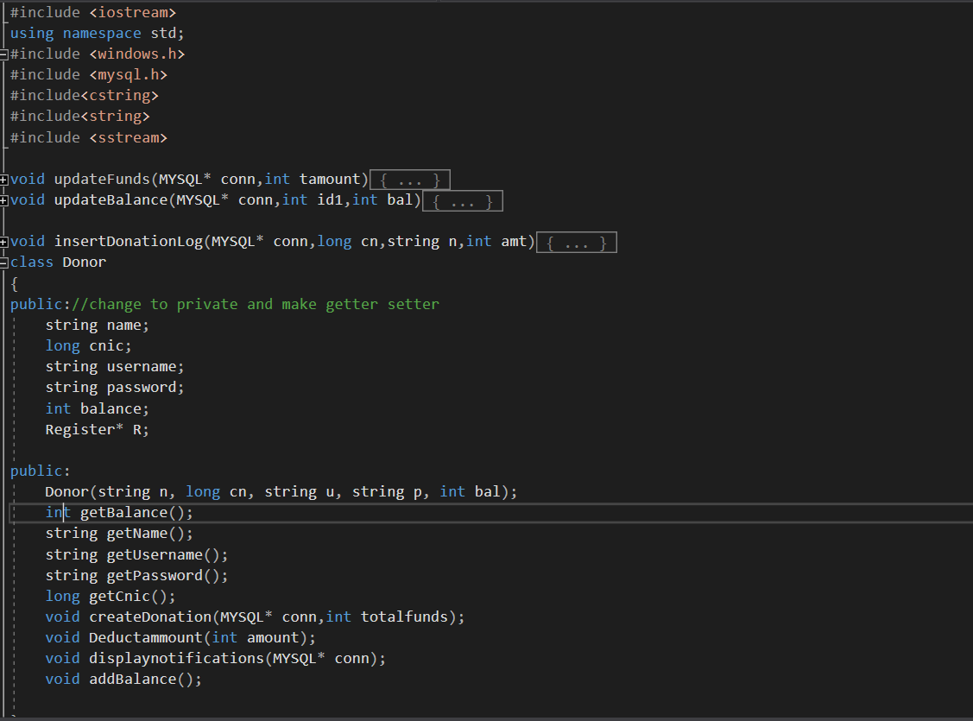

Admin.h:

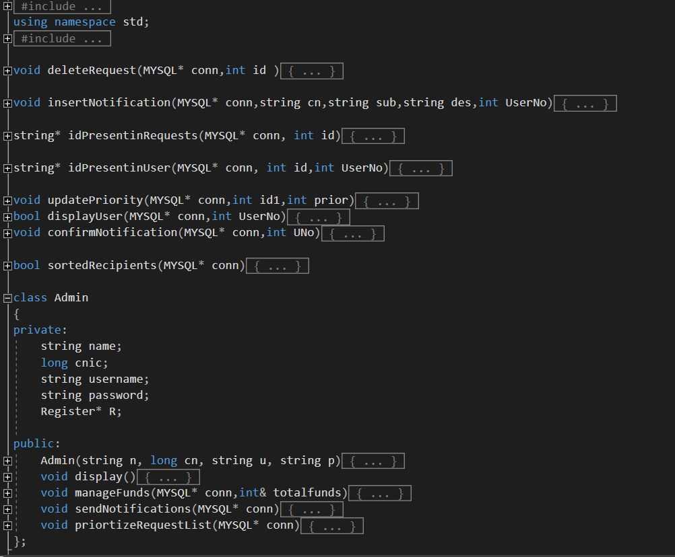

Register.h:

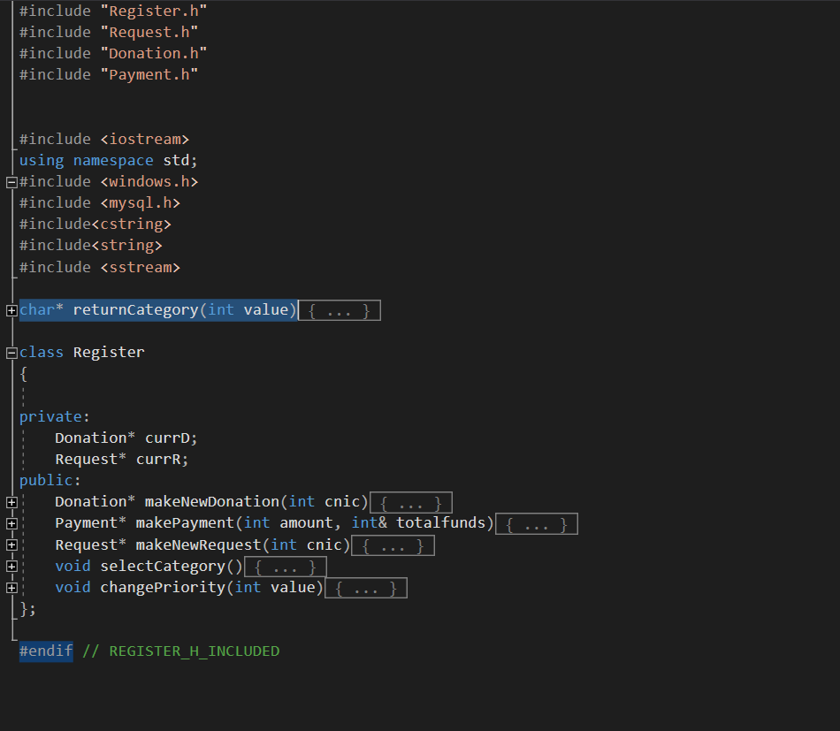

Request.h:

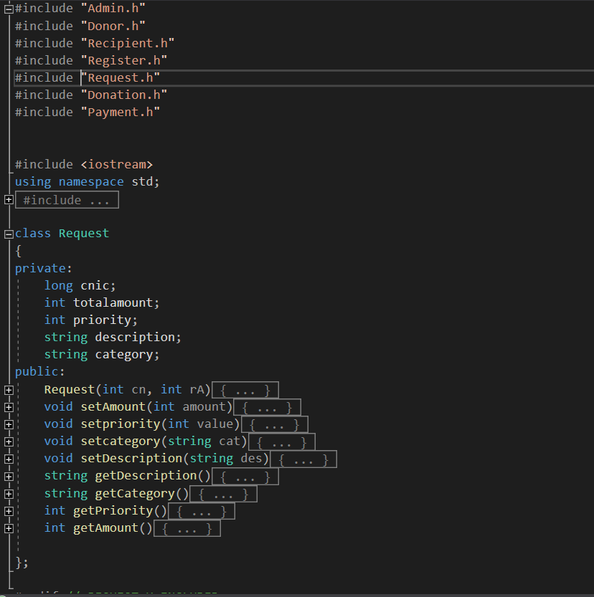

Donation.h:

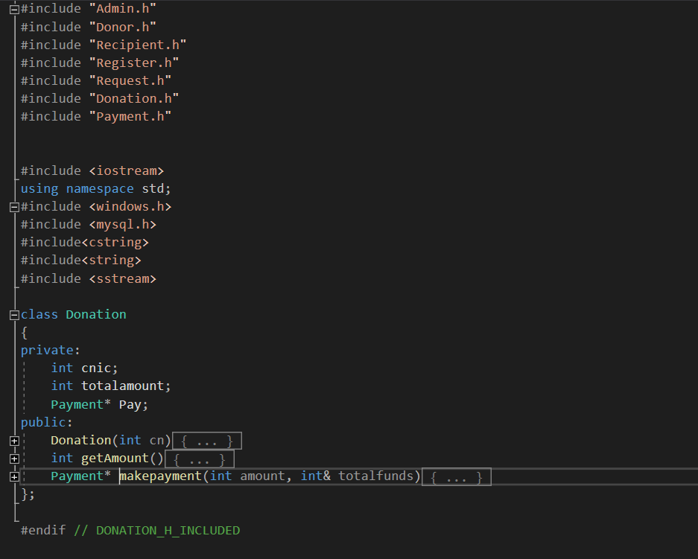

Payment.h:

